AI for Small Businesses: Affordable Tools That Deliver Big Results with Gridspark Solutions
If you run a small business, you already know the pressure.
You’re managing customers, handling operations, watching expenses, trying to grow — and probably doing half of it yourself. When someone mentions “AI,” it might sound like something built for tech giants, not small teams like yours.
But here’s the truth: AI isn’t just for big companies anymore. And it doesn’t have to be expensive or complicated.
When done right, it can actually make your day easier.
That’s exactly what GridSpark Solutions focuses on — practical AI that helps small businesses grow without overwhelming them.
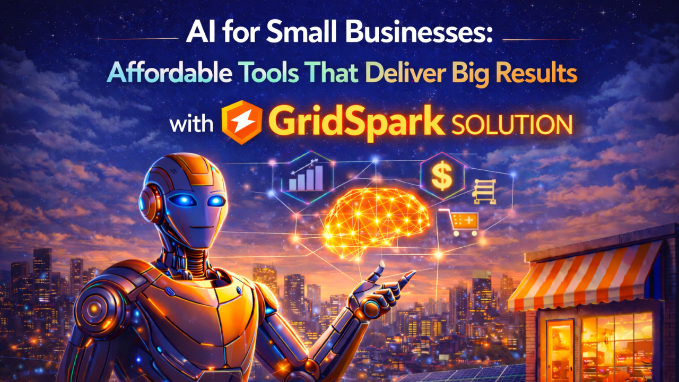

You Don’t Need More Staff — You Need Smarter Systems
Most small businesses don’t struggle because they lack ideas. They struggle because they lack time.
- Too many manual tasks
- Too many repetitive emails
- Too much data sitting unused
- Too many hours spent on things that could be automated
Imagine if routine work handled itself.
Imagine if customer questions were answered instantly.
Imagine if your sales data actually showed you what to focus on next.
That’s what smart AI tools can do.
And no — you don’t need a massive budget to make it happen.

GridSpark Solutions Keeps It Simple
One big fear small business owners have is complexity.
“What if it’s too technical?”
“What if my team can’t use it?”
“What if it disrupts everything we’ve built?”
GridSpark Solutions understands that small businesses don’t have time for complicated rollouts or long training sessions.
Their approach is simple:
- Understand your business.
- Identify where you’re losing time or money.
- Build AI tools that solve those specific problems.
- Make sure everything feels easy to use.
No heavy jargon. No unnecessary features. Just smart systems that quietly improve your workflow.

Affordable Doesn’t Mean Basic
There’s a myth that affordable tools don’t deliver serious results.
That’s not true.
When AI is designed properly, even small improvements can create big impact:
- Automating repetitive tasks frees up hours every week.
- Smarter data insights help you make better decisions.
- Predictive tools help you avoid costly mistakes.
- AI-powered support improves customer satisfaction instantly.
The key is not buying the biggest system. It’s choosing the right one.
GridSpark Solutions builds scalable AI systems, meaning you can start small and expand as your business grows. You invest at your pace — not someone else’s.

Real Results Matter More Than Fancy Features
You don’t need to understand machine learning models or algorithms.
You need to know:
- Is this saving me time?
- Is this increasing efficiency?
- Is this helping my business grow?
That’s the mindset behind GridSpark Solutions.
That is the mindset that drives GridSpark Solutions.
Every solution is based on actual outcomes, not fancy presentations. The goal is always practical development and measurable improvement.

A Partner Who Grows With You
Small businesses evolve quickly. What works this year may not work next year.
That’s why AI shouldn’t feel like a one-time purchase. It should feel like a partnership.
GridSpark Solutions stays with you. They refine, improve, and adapt systems as your needs change. It’s not about selling software and walking away — it’s about building long-term value.
And for small businesses, that kind of support makes a huge difference.

The Future of Small Business Is Smart, Efficient, and AI-Powered
AI is no longer out of reach for small businesses.
You don’t need a huge team.
You don’t need a massive budget.
You don’t need to be a tech expert.
You just need solutions that make your life easier.
GridSpark Solutions, with the correct advice and a business-first approach, transforms AI into something simple, affordable, and truly beneficial.
Because, at the end of the day, small businesses do not require complicated technology.
They need smart tools that work hard — just like they do.

